Lies My Teacher Told Me and Why They Are Important Today
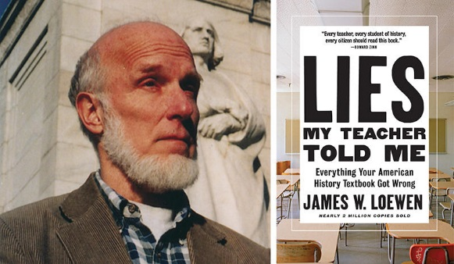
James W. Loewen
Monday, October 7, 7:00pm
Delano City Hall

James W. Loewen is the bestselling and award-winning author of Lies My Teacher Told Me: Everything Your American History Textbook Got Wrong (Nearly 2 Million Copies Sold), Lies Across America, Lies My Teacher Told Me About Christopher Columbus, and Sundown Towns (all published by The New Press) as well as Teaching What Really Happened, The Mississippi Chinese, and The Confederate and Neo-Confederate Reader. He has won the American Book Award, the Oliver Cromwell Cox Award for Distinguished Anti-Racist Scholarship, the Spirit of America Award from the National Council for the Social Studies, the Gustavus Myers Outstanding Book Award, and the Cox-Johnson-Frazier Award from the American Sociological Association. Loewen is professor emeritus of sociology at the University of Vermont and lives in Washington, D. C. He is speaking at the Minnesota Historical Society on Saturday, October 5 10:00 am. Go online to reserve seats.

A class will be offered before and after James Loewen presents:

Race, Religion, and American History

The text for the class will be Lies My Teacher Told Me: Everything Your American History Textbook Got Wrong. Participants need to secure their own copy. Sessions are scheduled for Saturdays, Sept. 14 and 28 from 10-12 at Delano City Hall. Participants will attend Loewen’s presentation on October 7. Then two classes will be held in late October and early November to complete the book study and course outline. The class is free. To register text: Shawne Worley at 612-709-5368 or sign up through Delano Community Education.

Sponsored by Delano United Diversity Task Force and St. Paul’s United Church of Christ, Great River Regional Library, Delano Community Education, and a grant from Chapel Hill UCC.

